Too Much

Daniel S.MILO

Daniel S. Milo. Israeli-born, his life is split between Paris, where he teaches philosophy and has published seven books (in French); and Tel Aviv, where he lives with his two daughters and is active in film and theater. Among the books, Betraying Time (Trahir le temps, 1991), an exercise in experimental history that impoverishes the past and its vestiges; and The Brain Bearers (Les Porteurs de cerveau, 2004), a Sci-Fi novel in which the N.I.E.T—New Institute for EThical Engineering—puts everybody on a diet: writers and filmmakers are forbidden from inventing new characters, cat-lovers have only three breeds to choose from, fewer and fewer brands of cereals are to be found on the shelves, all but three sexual positions are legally prohibited, only two among the hundreds of available psychotherapy techniques are permitted … There, as in his films and theater work, he keeps hammering home the point that the road to the True, the Good, and the Beautiful is arid. (Cf. Annex I: CV.)

Too Much, the book. A journey underpinned by two main axes: written language and visual proto-language. Each of the book’s pages triggers thinking that moves among distinct areas in the cerebral cortex—different and not overlapping. This canon for words and images gives the reader/spectator an experiential comprehension of abstract ideas, very different from strictly verbal formulations. It runs deeper. (Cf. Annex II: Too Much)

As someone who lives by his word, he uses philosophical language; but he also taps into a stock of visual connotations and associations. This book is an invitation to think with our own eyes.

Our brain is postmodern by nature. Fanatically democrat, it serves as a playground to innumerable, heterogeneous, incompatible stimuli. Yet relativity, pluralism, and ‘anything goes’, celebrated by postmodernism, are declared by Milo Man’s Cross.

And the profusion that arises from inside is so much greater than what the world outside has to offer … To yield to this siege will irrevocably lead us to death, for the point at which all phenomena, external and internal, become equals is called ‘entropy.’

One cannot fight the brain’s exuberance without help from the offender itself. Luckily, this wonderful machine complies by submitting reality to draconian measures. It ranges mess and simplifies it, it presses sense on chaos and represses the leftovers; it makes science and art. The most one can accomplish in this continuous drama are a few short stays in havens of order and necessity. Yet it’s worth the effort.

Milo finds his inspiration in Socrates, the self-proclaimed midwife of truth. Refusing to rely on the written word, the father of philosophy descended to the Agora to forcibly engender knowledge in people’s minds and bodies. Thus, the only philosopher who was accused of poisoning society and executed for this “crime” appealed to all the senses but one: reading. The written word is a new phenomenon, 3000 years old in the life the elite in some civilization, and several decades maximum for 99% of Humanity. So fresh is its memory, that there is no specific zone for reading in the cortex has been discovered by MRI and other techniques.

The written word was the right tool to promote the understanding of ideas, still is. But s/he who believes in comprehension, in transformation, in action, has to reach the eye, the ear, the nose; the palm and the skin. The philosophy of action will be oral and sensual or not at all.

*

Be Pro! This project is part of a great vision: to introduce professionalism in private life.

The shame! We give our best to strangers (workplace, public), best being the faculty to concentrate, as well as discipline, ritual, creativity, contract, time-table, dead-line, penalties, incitements; whereas the leftovers do we reserve to our dear ones (children, parents, friends): approximation, why not, improvisation, naturalness; amateurism. We may be major leaguers at work, sometimes – rarely - in society, but at home we are hardly little leaguers. Thus, our passions and our “true self” are consumed with persons unknown or almost, while petit-bourgeois pleasures do we enjoy with our kids and lovers.

Intensity goes with less, pleasures go with more; hence the battle we have to declare on Too Much. To be professional: in parenting, in loving, in friendship, in accompanying a dying mother, in mourning this very same mother – is part and parcel of this noble aim. To be a pro is to be immunized against whatever is irrelevant to that which is at stake in this particular moment. To be a pro is to suspend the rest. To be a pro is to refuse excess. It is to die to the world at large and to live in the present.

*

Too Much: Catalogue and Exhibition. The poem “Too Much” will serve as skeleton to an exhibition in a great museum. We shall invite our host inside the project through its permanent collection.

We shall invite contemporary artists, but also whoever provokes the eyes: architects, comics’ creators, fashion designers, photographs to join in the book/catalogue/exhibition. A list will be established of some forty image-makers, who will submit their response to the sentences already written. Every preexisting image is a candidate to be replaced by the participants.

A multi-linguistic DVD will circulate worldwide. In it: the “poem” Too Much recited in as many languages as possible, and the images already chosen – and candidates to substitution. Thus the invitees will have to respond to the seen-and-heard work only.

*

Too Much and Google. Too Much is Internet's illegitimate daughter. Without the Web, its creation would have taken two years to an encyclopedic expert in the visual, and to your humble servant, a philosopher with solid artistic luggage sans plus, five to ten (to use penal jargon). Google Images it was that played a decisive role in this work.
For the Web, and Google as its ultimate incarnation, are the mirror of Brain's grandeur and horrors. The proliferation of information and the mastery of this exponential proliferation are Google incarnated. Since one cannot fight the brain without the offender's help, let the war against excess take place in the exhibition itself.
Each image will be accompanied by the relevant verse (in many languages). Some 80 computers – depending on the number of the works exposed – will be installed in front of each and every visual, allowing access to one server only: Google Images. Feeling dissatisfied with a particular image - the text being the constant -, or just tempted by choice, the visitor is invited to surf among the trillions of images offered by this site; let him pick an alternative one. Color printers will be available, prepaid cards too, so he’ll be able either to add his option to the catalogue already purchased, or to create a totally new catalogue of Too Much: his own. The memory of all the options will be stocked, for further visitors. That’s “thinking with his own eyes” in action.

The book displays the brain’s techniques in handling excess; the paradox being that this very brain is also our main purveyor of excess. Fanatically democratic, it serves as playground to innumerable, heterogeneous, incompatible stimuli.
.
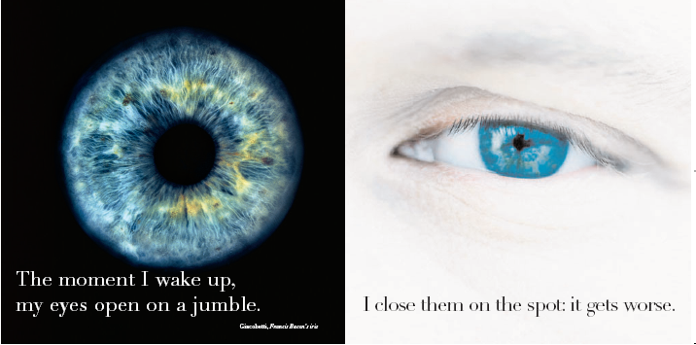

24 hours a day we are bombarded with data we couldn’t care less about (you'll count me as one till contrary proven ...) The overdose that arises from inside — the "psyche" they call it— is stronger and oppressive than the excess from the world around.

To yield to this siege will irrevocably lead to death, for the point at which all phenomena, external and internal, become equals is called "entropy". Alas, one cannot fight the brain’s exuberance without help from the offender itself.
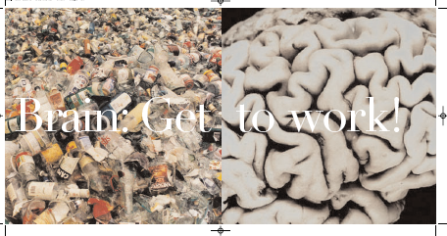

Luckily, the most wonderful of machines complies. It arranges mess and simplifies it.

It presses sense on chaos and represses the leftovers; it makes science and art.

The most one can accomplish in this continuous war is a few short stays in havens of order and necessity. Yet the engagement is worth the effort.

Too Much mobilizes Mondrian, Turner, Géricault, Chardin, Bosch, and Cranach, as well as Beuys, Andy Warhol, Sylvie Fleury, and other contemporary artists. Canonical works appear in it alongside an eclectic panoply of images: two demographic maps, an MRI of a brain afflicted with Alzheimer’s, a detailed sketch of the evolutionary tree, a close-up of Francis Bacon’s iris, Freud’s couch, an assortment of Ecstasy pills, and so forth.

Each of the book’s pages triggers thinking that moves among different areas in the cerebral cortex, and some aim deeper, to the limbic brain if possible (the reptilian one being beyond reach). The dialectic movement between word and image produces an experiential comprehension of ideas whose formulation in words alone would not extract from the reader the same physical internalization of an abstract idea.
This is no illustrated book in any conventional sense. The image no more illustrates the text than the text illustrates the image, and their overlapping, page after page, generates a new plane—the plane on which knowledge occurs.

